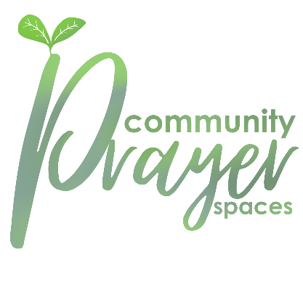
Designing a Christian Community Prayer Space
A community prayer space is a simple space or installation with something to look at or do that provokes/inspires prayer and personal reflection. They can be in any indoor or outdoor space in which people meet – e.g., park, school, church, workplace, bus, fete or community event.
They should be flexible and open, and yet they do need some structure so that participants can engage with them easily and confidently. We recommend that you provide simple instructions including: -
- A short introduction/explanation of the station itself - “This is a prayer wall…” “This is “pray dough” …”
- Simple directions/instructions - “Take a piece of cardboard...” “Stop and breathe slowly...” “Look at yourself in the mirror...”
- One or possibly two questions that encourage reflection - “How did you feel when...?” “What do you think this might tell you about...?”
- Some encouragement e.g. a quote from the Bible, around the prayer station theme.
- An open invitation to turn thoughts into prayer: “If you want to prayer for…” “You could you pray this prayer…”

When gathering ideas together, whatever their source, ask yourself - is this simple? Would someone who has no experience of God or church, or faith understand how they can participate in this activity, within 10 seconds of reading the explanation? And - is this prayerful? Would someone who has no experience of God or church, or faith feel welcomed into honest, simple prayer and into personal reflection? If yes, go for it.
Examples of community prayer spaces, many of which are also appropriate for use in schools can be downloaded at Suffolk in Prayer
We would love for copies of the Suffolk Jubilee prayer (overleaf) be provided at each community prayer space. You can download an easy-to-print prayer card at www.suffolkinprayer.uk/jubileeprayer
