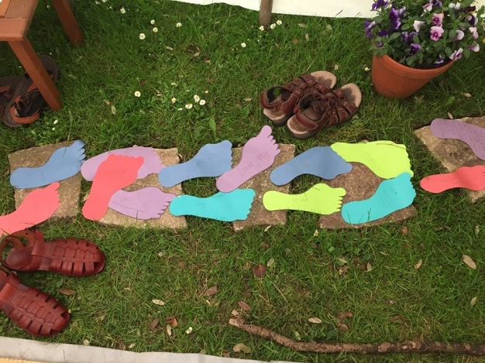
Examples and Ideas for Community Prayer Spaces suitable for use in schools

A special note on Prayer Spaces in Schools
Children and young people are innately curious about life. Many have an interest in the non-material aspects of life, the spirit or soul, and want to explore how these ideas and experiences help them to develop their own sense of identity, self-worth, personal insight, meaning and purpose.
Taking a broadly Christian perspective as a starting point, prayer spaces give children and young people an opportunity to develop skills of personal reflection. The approach does not proselytise but purposefully allows pupils, of all faiths and none, to explore life questions, spirituality and faith in a safe, creative and interactive way. Enabling them to make their own meaning and to draw their own conclusions.
Prayer spaces can also be a valuable contribution to schools’ statutory responsibility to support the spiritual, moral, social and cultural development of the pupils.

Community Prayer Spaces are working with the national organisation “Prayer Spaces in Schools”. Find out more at Prayer Spaces in Schools

Fruit of the Spirit

Christians want the fruit of the Holy Spirit to grow in their lives: This doesn't mean apples and bananas - but good qualities. In the bible it says,

“The Fruit of the Spirit is
Love, Joy, Peace, Patience, Kindness, Goodness, Gentleness, Faithfulness, Self-control.”
Galatians 5.22-23

Eat a grape and think about which one of these qualities you would like to grow in your life
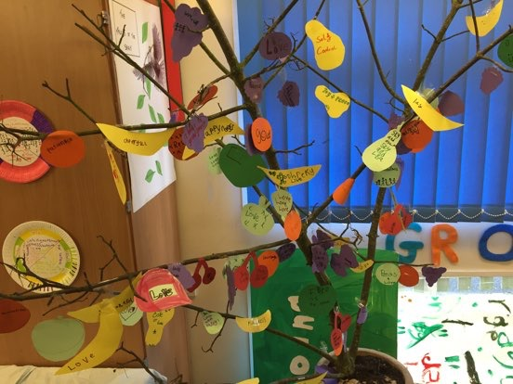
Write it on a fruit-shaped piece of paper and hang it on the tree. You could pray, “Dear God please grow the fruits of the Spirit in my life.”
Fruit of the Spirit continued

If you would like to, try this Breathing Prayer
Breathe in: Come Holy Spirit
Breathe out: Bitterness
Breathe in: Love
Breathe out: Busyness
Breathe in: Joy
Breathe out: Stress
Breathe in: Peace
Breathe out: Impatience
Breathe in: Patience
Breathe out: the need for my own way
Breathe in: kindness
Breathe out: indifference
Breathe in: goodness
Breathe out: carelessness
Breathe in: faithfulness
Breathe out: hardness
Breathe in: gentleness
Breathe out: recklessness
Breathe in: self-control

Repeat as many times as you wish.
Be Still
This sofa is a place to sit and be still – ready for prayer.
Hold a shell, pebble or piece of wood gently in your hand. Look at it. Does it feel smooth, or rough? Is it heavy or light? Is it brightly coloured or dull? Don’t speak, just hold it.
Now you are still and calm, look at the pictures on the screen.
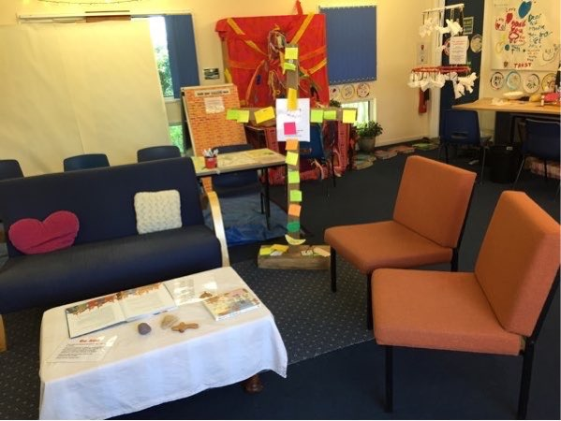
What are you feeling now?
Pray Dough!
You can pray or just think quietly while you are making things out of the dough
- Make a ball- Pray for the world
- Make a messy shape – Pray about something which has gone wrong and ask God to put it right
- Make a heart – Pray for people you love and for those who need love
- Make a cross – Pray for people who suffer
- Make a loaf of bread – Pray that God will meet our daily needs

Post-it Prayer

You can write your heart-felt message to God
on a post-it
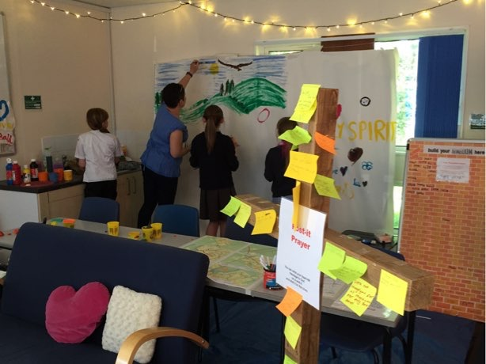
and stick it on the cross.
Prayer Map

- Find your house or a place you like to visit on the map
- Think of the good things you would like to happen there
- If you wish, tell your hopes to God in a prayer
- Colour in the street or mark the building with a spot of colour.

Parts of a Body

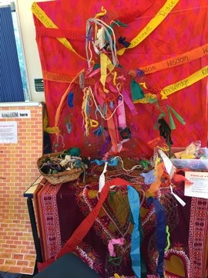
In the Bible it says that God’s people are like a body. The Holy Spirit is like the breath of the body and people are like the different parts. Life is best when we share and work together. If this school were a body, which part would you be?

eyes - good at noticing things
ears - good at listening
mouth -good at talking
brain- good at thinking
hands- good at making things
heart - good at caring
feet - good at moving around

- Tie a ribbon or cord onto the part of the model body you have chosen
- Think - How can you use the thing you are good at to help other people?
- If you want to pray: Dear God, help me to use the things I am good at to help other people. Amen
The Holy Spirit is like Wind

Jesus said the Holy Spirit is a bit like the wind. The wind is invisible. We only know it’s there by watching things being blown about. The Holy Spirit is invisible too, but Christians believe that you can tell he’s there by the way he moves or guides people. For example, the Holy Spirit might move people to be kind, wise or brave.
Feel the wind from the fan. (Please ask if it needs to be turned on.)
If you want to pray, “Holy Spirit, guide my life.

Holy Spirit - like Fire

After the Holy Spirit, the disciples start spreading the Good News of Jesus. One of the symbols of the Holy Spirit is a flame of fire. Fire catches - you can pass on the flame of a candle easily from one candle to another. Every time the followers of Jesus passed on the message of God’s love, it was as if a flame was passed on, lighting up the world.

When we have good news to tell, it is natural to want to spread it.

What good news message would you like to tell?

Choose one of the flame shapes.
Write on some good news that you would like to tell. Stick your flame on the large black sheet.

If you want to pray,
“Dear God, help me to pass on good news”
Holy Spirit - like water
Water refreshes us, cleanses us, helps us to grow: Jesus said God’s Holy Spirit was like water, satisfying our thirst for goodness:
On the last day, the climax of the festival, Jesus stood and shouted to the crowds, “Anyone who is thirsty may come to me! 38 Anyone who believes in me may come and drink! For the Scriptures declare, ‘Rivers of living water will flow from his heart.’” 39 (When he said “living water,” he was speaking of the Spirit, who would be given to everyone believing in him. John 7.37-39

Sip some water. Think about your thirst for goodness, joy, love and peace - If you want to you can pray,

Lord,
I am thirsty
Fill me with the Living Water of your Holy Spirit.
Amen
Holy Spirit
like a Dove

Read the story of Jesus’ baptism from a bible or children’s bible.
When Jesus was baptised the Holy Spirit, came on him like a dove.

Make a paper dove.
Hang it up and remember that you are a “beloved” child too.
If you want to pray, “God, Thank you that I am your Beloved child.”
International

On the day of Pentecost, the Holy Spirit helped the believers to speak in different languages. Today there are about 2 billion Christians scattered throughout the world.
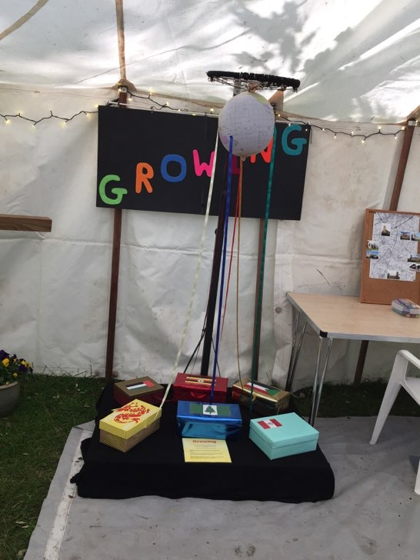
Look
Follow the ribbons from the boxes to the globe to locate each country.

Discover
Choose a box and discover more about that country.

Pray
Christians believe that God loves all the countries in our world. Place a heart in the box which you have learned about and if you wish, pray for the Holy Spirit to bless that country.

Sorry

In the Bible it says that if we confess the wrong things we have done to God, he will forgive us.
Think of something you’ve done that you want to put right. Write it on a small piece of paper.

If you want to pray, “Dear God, please forgive me for what I’ve done wrong.”
Shred up the paper to remind you of God’s forgiveness.
Healing

When Christians pray for someone to be healed, they often use oil which is a symbol of healing
In the bible it says…

Is anyone among you sick? Let them call the elders of the church to pray over them and anoint them with oil in the name of the Lord. And the prayer offered in faith will make the sick person well; the Lord will raise them up. If they have sinned, they will be forgiven. James 5:14-15

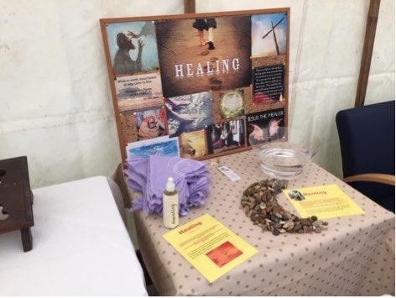
Think about someone you know who needs healing. Place some oil on a “handkerchief”. If you want to, pray for the Holy Spirit to help or heal them.
You may keep the handkerchief if you would like to.

Your Kingdom Come

In the Lord’s prayer, we say” Your Kingdom come”
This is a prayer that God will rule over us
Christians believe that God’s Kingdom means love, fairness, joy and peace for everyone.

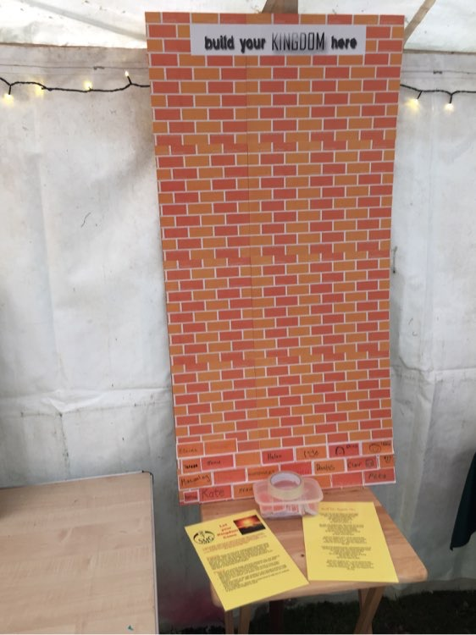
Some people have put their name on a brick and stuck it to the wall to show they want to help build God’s Kingdom. They want to make the world a happier, more caring, fairer place.

If you would like to join in this prayer, write your name on a brick and stick it to the wall.

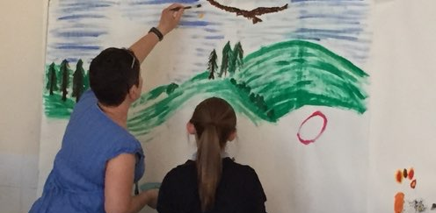
Prayer Painting

Paint your prayers and praises on the wall

